New Entrepreneur
[target users]:
independent designers
hand making staffs e.g. Maddie Bradshaw,
graphic design,
photographing,
fashion design e.g. modcloth
pastry chefs e.g. Jeni Britton Bauer,
counselors, Planning designer (interviewed),
video makers,
music makers,
programmers, e.g. Daniel ek

[user characters]
Info concerned
creative
fun
flexibility
visual thinking
multi-field working

[problems & needs]
-Networking (easy to contact both online and offline)
-Hire people or get an outsourcing job
-Find people alike(like-minded, on the same level)
-Advertisement (set up image, enhance well-known)
-Feedbacks from others(how others think about their works, directions )
-Show, share(works, dayflies)
-Business management(simplify the operation, easy to catalogue)

[“idea stall” (interim)]
[overall]
<stalls street>
The site will show many little stalls run by different independent designers.
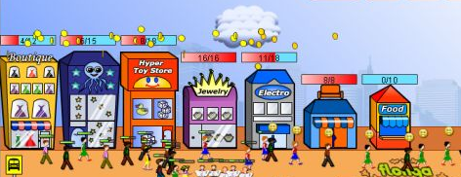
(Shopping Street Strategy http://hubpages.com/hub/Shopping-Street-Strategy-Level-7)
(http://www.clipartguide.com/_pages/0511-1009-2317-0550.html)
After entering a stall, users can see the designer’s works (can be catalogued), ads of the stall, and the stall keepers’ information (contact numbers, e-mails, pictures…).
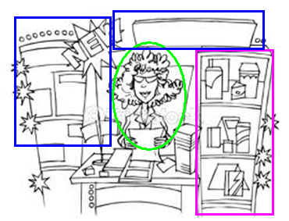
(thinkshockphotos.com)
Users can click a piece of work to see details, there can be several pictures, text graphs, or videos to show the work. You can make a comment or add the work to favor. For some works, you can get its links to eBay, taobao.

<Message board>
There is a public “message board” which is open to every registered user. Users can post their new ideas, job notices, activities plans, latest news....on the board, add any message to their favors, add comments…
*and all the messages can be catalogued and show in different colors(interim)
-green(opinions, ideas)
-blue(I want to hire..., I want a job... )
-red(activities, meeting, party)
-grey(news finding)
[users & features]
-Tourist user (see all the stalls & works, see part of the user’s info)
-Normal registered user (all above, add comments & favors, using message board, edit personal info, give a private message to a stall owner )
-Owner of a stall (all above, upload new works, decorate stalls, add links)
-Site administrator
#using “tags” to catalogue people & works, users can add tags to themselves and the works they have done

